Missionary Newsletter from East Angola Annual Conference
Missionary: Kutela Katembo Dieudonne
Mission: UMC Quessua Agriculture Center

E-mail:kkatembo@umcmission.org Tel: (00244) 925213393

May 30, 2023

Dear Faithful brothers and sisters in Christ, Receive our warm greetings from the Quessua Agriculture Center. We hope that our newsletter finds you well and healthy by the grace of our Lord Jesus Christ.

Crop production
The Quessua farm recently harvested this year’s maize crop, with a resulting great production due to extending the maize fields from 5 to 10 hectares.
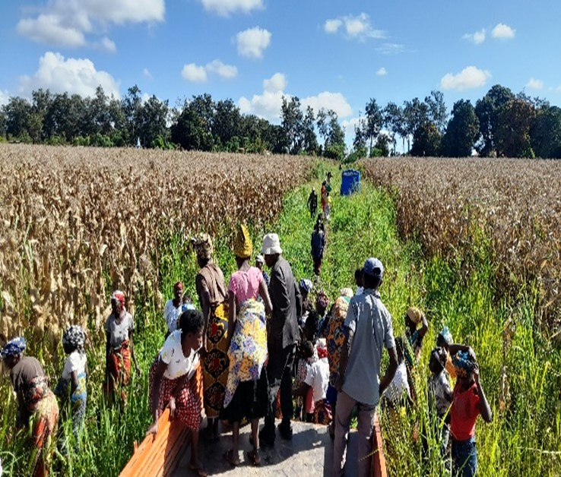

Mufungo Community arriving at the corn field to manually help harvest the crop.

Manual harvesting is slow and takes us around 2 months, for this reason, it is our prayer to obtain a maize harvester, even though we know that farm equipment is very costly in Angola.
Our dream to extend our corn field to 15 or 20 hectares will be possible with the acquisition of this harvester.
Testimonies from the community regarding our support to them are thrilling and encouraging. They have been harvesting their bean and vegetable crops grown with seeds provided to them by the Quessua farm. It is such a pleasure for us to hear that our brothers and sisters that we serve are harvesting food that will help sustain their families. Widow Antonica recently sold some of her bean crop at the little market here at Quessua. She saved most of it for consumption but being able to sell a small amount provides her with some cash for other needed household purchases like oil, salt, and soap.

Most of the people are subsistence farmers hence we feel led to support them frequently since by themselves they cannot afford to buy expensive seeds. Many of them are elderly and widowed, lacking the strength to cultivate a large plot of land like they did when they were younger.
Then there is 13-year-old Gia who one day explained that “for the last 4 days the main food for their meals has been Papa Kutela Beans”. How heart-warming to hear!

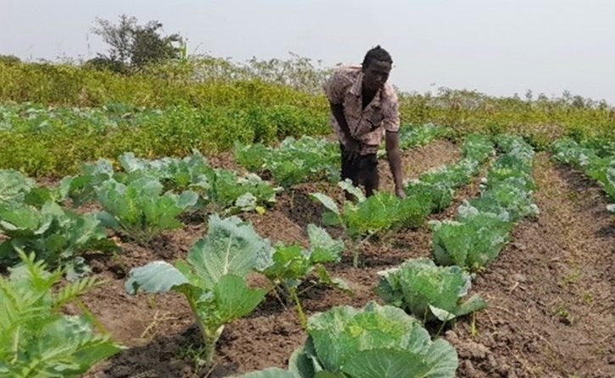
Mufungo farmer with her cabbage plot.

Pig production

The newly constructed piggery is already accommodating a recently purchased, quality breed of pigs; 12 female pigs and one male. Pigs are high producers giving birth three times a year; thus, we already have 40 piglets.
The communities that we serve will be organised in groups of 20 motivated individuals who together will receive and raise a pair of piglets to rear in their village.
The project idea is to increase food security through the promotion of pig production in our vulnerable communities. The pigs will provide a valuable protein source as well as income from sales. Since pigs multiply rapidly the community will be able to share piglets amongst themselves and to the needy in our wider communities.

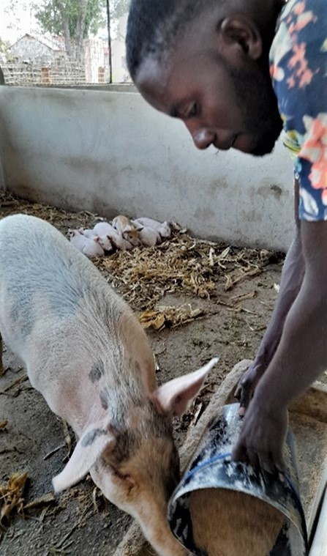
Farm worker Caitu feeding a sow with
Her piglets in the background

Peanut Production

The invaluable help of our village communities was crucial to a successful peanut harvest. Planting, weeding, and harvesting peanuts is labour intensive and without their help it would have been difficult for the few farm staff to accomplish. Equally time consuming is the separation of the peanuts from the plants. The village groups took their turns doing this over several weeks until the process was finished. During this time, missionary dentist, Dr Sergey, who serves at the Quessua hospital, came to give an oral hygiene explanation and demonstration to the villagers working. Oral hygiene teaching is sorely lacking in our community and Dr Sergey treats many with severe gum disease and tooth decay. The community received the information with interest, particularly learning when and how to brush their teeth. Tooth paste and toothbrushes were joyfully received by each.

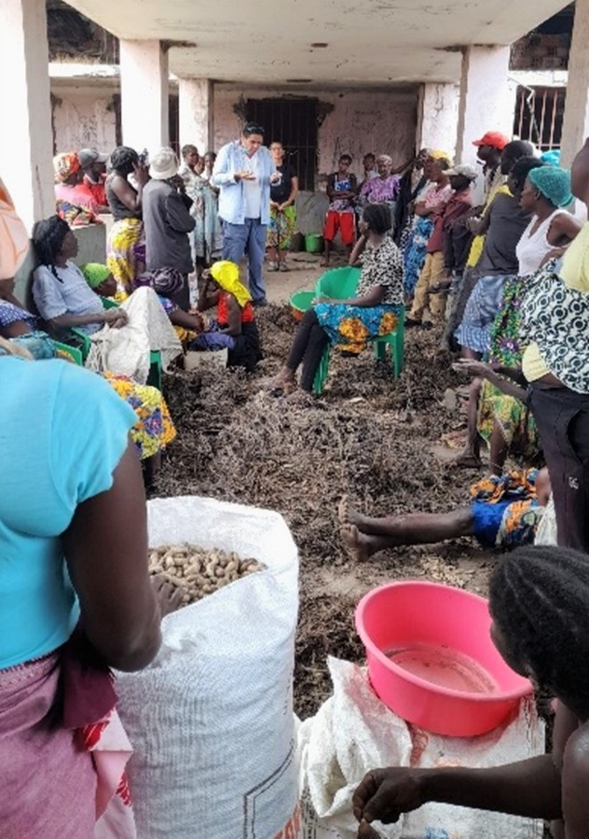
Dr Sergey and Ruthie Schaad giving an oral hygiene talk and demonstration to the Paz and Cassembele Community agriculture groups

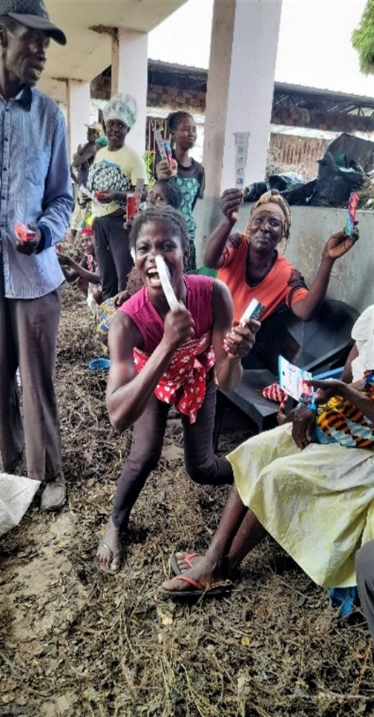
Paz and Cassembele villagers receiving
toothpaste and toothbrushes

The peanut production was part of a small pilot project for the fabrication of RUTF (ready to use therapeutic food) at Quessua mission. Visiting missionary groups from the Florida conference recently made the first bags of the RUTF with the harvested and cleaned farm peanuts. The RUFT is being selectively distributed to needy elderly in the community, particularly some that were identified during recent cataract operations at the Quessua hospital. The elderly, like young children are often the family members that lack adequate nutrition in a perpetually underfed community.

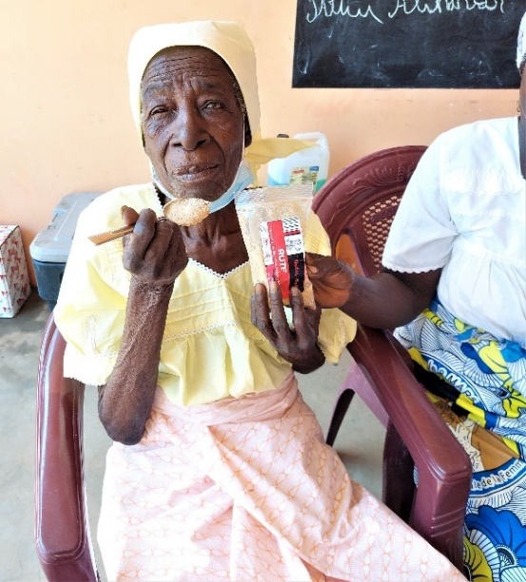
Recovering from cataract surgery, Mufongo villager and former chief, 96-year-old avó Joanna trying her first RUFT.

ADVANCE SPECIAL NUMBERS:
Partner with me,
I am very grateful for the support you continue to give to our project and to myself the
missionary. There are two ways to make your contributions:

-Advance # 3022272(Quessua Farm Project support)
-Advance#3022031(KUTELA Salary support)

. Utilizing the Global Ministries website: www.umcmission.org. To donate for my project and salary support, at the bottom of the page, click on “Missionaries”, scroll to my name on the page and my profile will appear. At the bottom of my profile is a link to make an online donation.

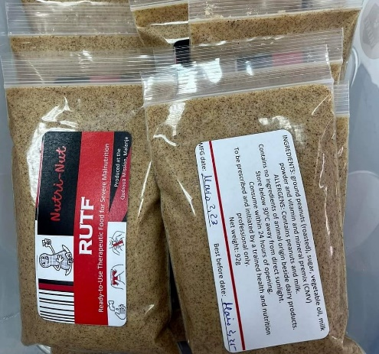

2. Mail a check. Make your check payable to ADVANCE GCFA.Write “For support of Missionary Kutela Katembo.
Advance # 3022272 or # 3022031”Send your check to ADVANCE-GCFA, 458 Ponce de Leon Ave.N.E; Atlanta, GA. 303083. Through your Conference office indicating “for Kutela Katembo”,

STAY IN TOUCH!

I thank you for your support and friendship. Please stay in touch with the Quessua Agriculture CenterTeam on the following platforms:
Email: kkatembo@umcmissio.org Facebook: @QuessuaAgCenter

God Bless you! – Kutela

