Missionary Newsletter from East Angola Annual Conference
Missionary: Kutela Katembo Dieudonne
Mission: Quessua UMC Agriculture Center

E-mail: kkatembo@umcmission.org/kutelaka@gmail.com Tel :(00244) 925213393

April 2022

Dear friends and family in Christ, I greet you all in the name of our Lord Jesus Christ. Today we remember Jesus´ sacrifice and give thanks for what he brought to our world. He is risen! Wishing you a blessed and holy Easter!
The year 2021 was a blessing for the Quessua agriculture center and we continue with the hope for the same this year and that God will open up more ways and means for the accomplishment of his mission. In the name of the Quessua Agriculture Center team we say thank you so much for your support that enables us to still be in this mission, serving with the needy and poor of God’s communities.

Crop production

Abundant rainfall received this year resulted in successful corn production. This was a blessing after last year’s poor harvest due to lack of rain. Maize harvesting by hand is slow
and laborious hence we appealed to the communities that we work with to help us with the harvest. With their help it took us around 2 weeks to harvest the corn.
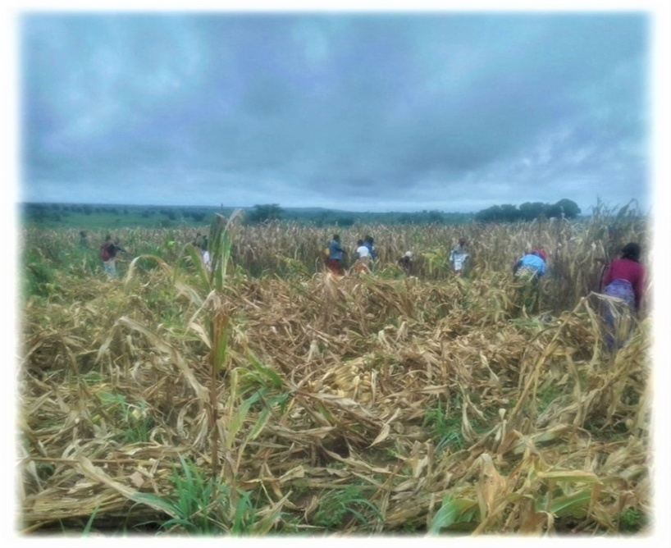
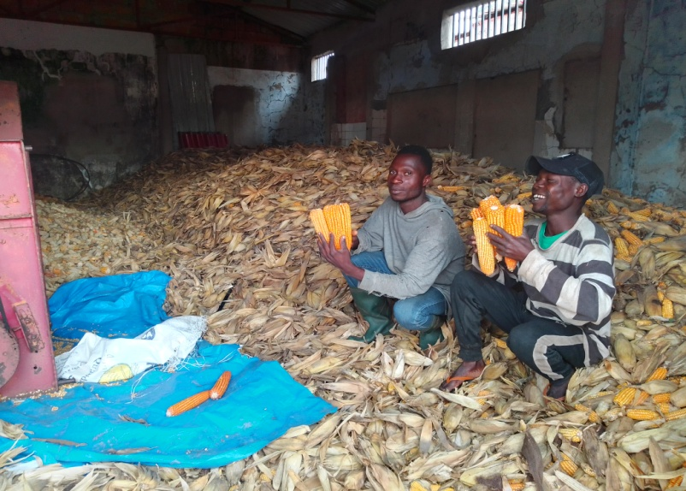
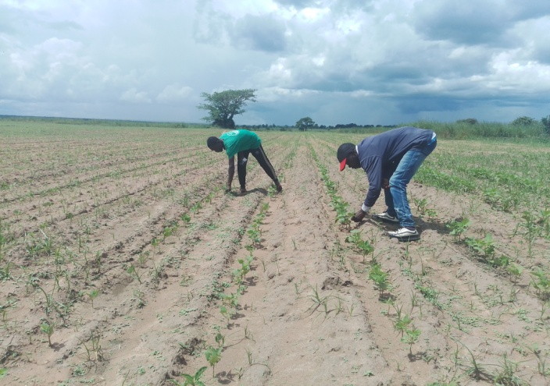
Beans field
Maize harvesting with the community
In order to help us, women and men leave their own work behind for some hours showing their support to the Center that supports and collaborates with them in various ways.
The Quessua Agriculture Center prepares a welcomed meal of rice and beans for the community after their great help in the field.

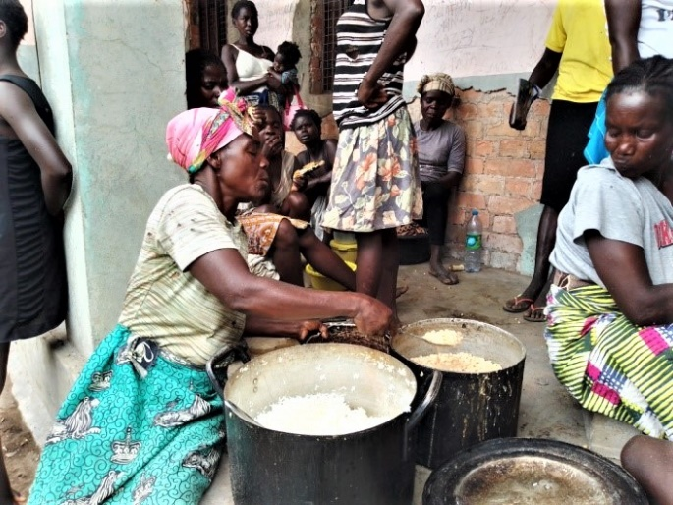
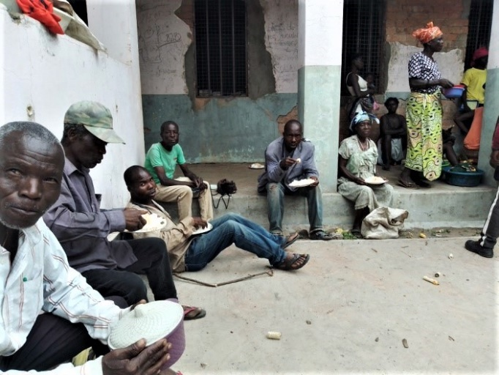
Food insecurity in the community is a major issue contributing to malnutrition, particularly, in children. During the past three years, Angola has experienced climate change disturbances that drastically reduced both subsistence and commercial agricultural
harvests in the region due to insufficient rainfall. This, followed by the covid pandemic has torn apart individual family economies and agricultural food reserves in many households. The two situations have led to increased undernourishment and malnutrition in already vulnerable families. As is so often the case, children less than 5 years old are the most affected. Subsistence agriculture is the primordial activity of the peasant farmer and is the main and sometimes only source of food for their livelihood.
Access to food has become a luxury in so many Quessua families that having two or three meals a day are practically impossible for them, thus they learn to survive on one and some days none. Children come to school hungry or else don’t come at all if they have not eaten the day before. Given this reality, the nutritious meal provided every Sunday to children after Sunday school is for many of them the most substantial and nutritious of their week. These meals are managed by fellow Quessua missionaries and the farm provides vegetables when they are available. With the abundance of lemons on the farm now, these are also given to make juice with, something the children love.
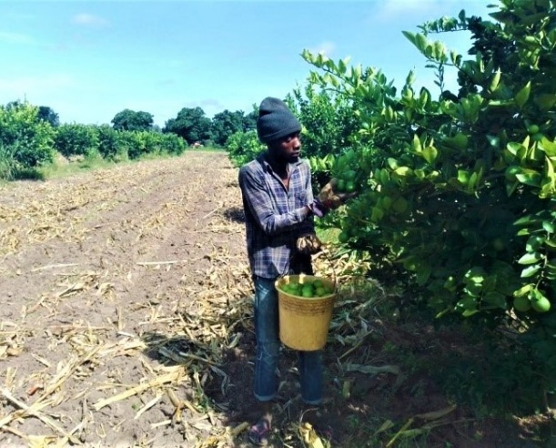
Ever since the Quessua Agriculture Center restarted after many years of nonexistence, it has been and continues to be a pillar of support for the surrounding communities. We help these needy whenever possible with agricultural inputs such as seeds and tools.
We are all familiar with the proverb, “Give a man a fish and he will eat for a day. Teach a man how to fish and you feed him for a lifetime”. We strive to help families grow and provide food for their families for their lifetimes hoping that this will help them provide for their malnourished children.
The Quessua Agriculture Center is looking forward to raising funds for its vulnerable communities to provide them with watering cans and seeds for vegetable production. Seeds remain very expensive here and their purchase unattainable for most households.
ADVANCE SPECIAL NUMBERS:
Partner with me,
I am very grateful for the support you continue to give to our project and to myself the missionary. There are two ways to make your contributions:

-Advance # 3022272(Quessua farm project support)
-Advance # 3022031(Kutela salary support)

1. Utilizing the Global Ministries website: www.umcmission.org. To donate for my project and salary support, at the bottom of the page, click on “Missionaries”, scroll to my name on the page and my profile will appear. At the bottom of my profile is a link to make an online donation.

2. Mail a check. Make your check payable to ADVANCE GCFA.Write “For support of Missionary Kutela Katembo.
Advance # 3022272 or # 3022031”Send your check to ADVANCE-GCFA, 458 Ponce de Leon Ave.N.E; Atlanta, GA. 303083. Through your Conference office indicating “for Kutela Katembo”,

STAY IN TOUCH!
I thank you for your support and friendship. Please stay in touch with the Quessua
Agriculture Center Team on the following platforms:
Email: kkatembo@umcmission.org
Facebook: @QuessuaAgCenter

God Bless you! - Kutela

