Missionary Newsletter from East Angola Annual Conference
Missionary: Kutela Katembo Dieudonne
Mission: Quessua UMC Agriculture Center

E-mail:kkatembo@umcmission.org Tel: (00244) 925213393

January 2023

Dear Faithful brothers and sisters In Christ, I greet you all in the name of our Lord and Savior, Jesus Christ. I hope that the year 2023 finds you all well and healthy by the Grace of the Lord.
At the start of this new year, I would like to take this opportunity to thank you for your tremendous support during 2022. Your blessings have brought life to some of the communities that we serve and they in turn are happy and gracious. I believe that together we will continue to show the love of God through this ministry. May God’s blessings be with us in this New Year and continue to strengthen us spiritually and physically so that we lift up his mission in the world.
I thank God for the grace of life and am happy to say that my family and I are doing fine and thankfully, we had the chance to gather together during Christmas and New Year.

A lot has been happening within the community we serve at the Quessua Agriculture Center. As always, our main objective is improving community livelihoods. After empowering the community vegetable

production with seed distribution, we were able to further this by issuing hoes and machetes. These are tools essential to helping villagers to prepare the land for upcoming seasonal crop production of beans and peanuts once the second rains arrive.
Witnessing the joy and happiness on the faces of beneficiaries upon receiving their tools certainly confirms the value of this effort. One could see in their faces that this gesture went beyond their comprehension. The people are extremely grateful and thankful to God. What I mostly hear from them that is so touching to my heart is them saying: “May God bless the donors and sources of these gifts and may God repay them a hundred times”. The Quessua villagers live in a world where they often feel abandoned, marginalized and forgotten so these seemingly small gestures validate their lives more than we can ever know.
The community knows that this blessing is coming from you, and they always pray for you.

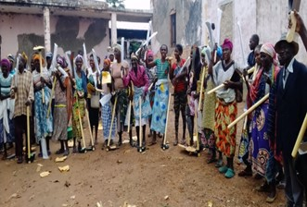

Collaborating with some of our project supporters, the Quessua farm has launched a pilot project for peanut production. The plan is to use the peanut to make RUFT (Ready-to-use Therapeutic Food) for treatment of severe acute malnutrition in children. The project has been welcomed by the community and they have eagerly participated in the cultivation, weeding, and now harvesting of the peanuts.
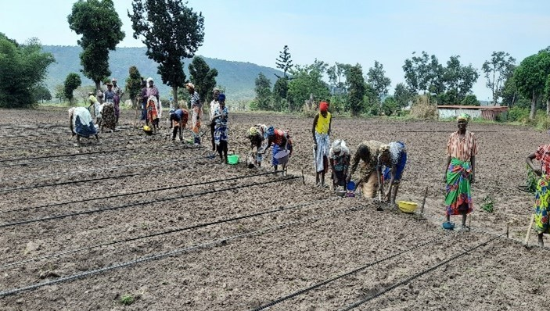

Cultivation of peanuts is labour intensive, thus without the support of the village ag extension groups it would be very difficult to implement with our small number of farm staff.

Planting of peanuts by village ag groups

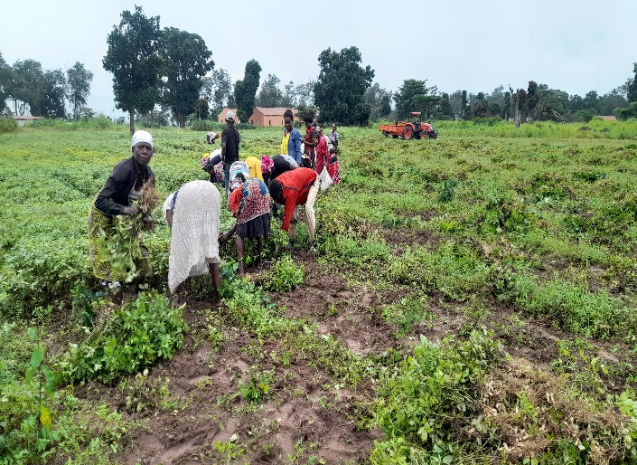
Peanut harvesting
Pig Production
The Quessua farm is expanding the production of pigs. We have recently finished construction of a piggery with capacity for 18 stalls for female pigs and we are expecting to receive the pigs by the end of February. The community we serve will be put into groups for those wanting to rear pigs and will be given a couple of piglets to start with. We will encourage the community to share their production with others.

We have another dream for this year! Poultry Production with emphasis on egg production! To accomplish this, we need to build a large chicken coop building for laying chickens. The eggs will be beneficial for the malnourished children of the community as well as for the long term financial self-sustainability of the farm. Together this dream for 2023 can be alive!

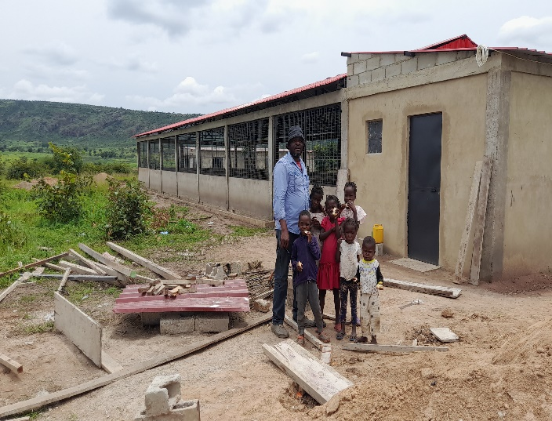
The new piggery. Kutela with some of the farmworker children

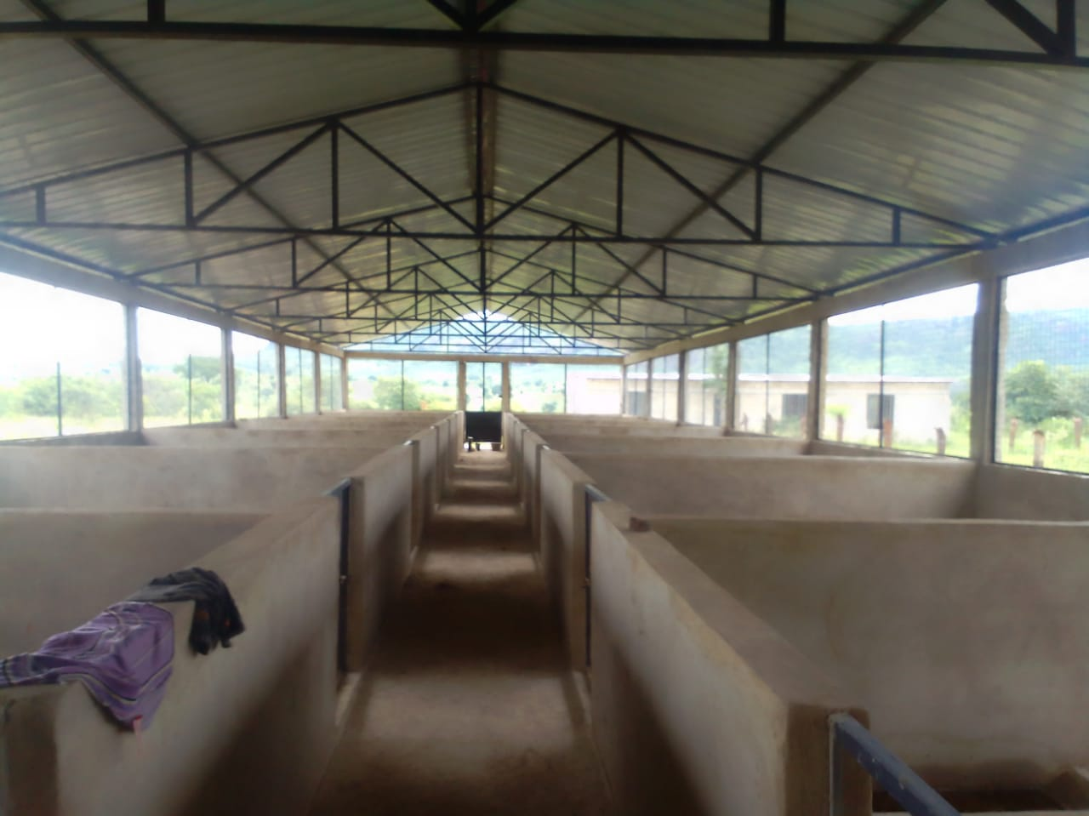
Inside the new piggery

₂
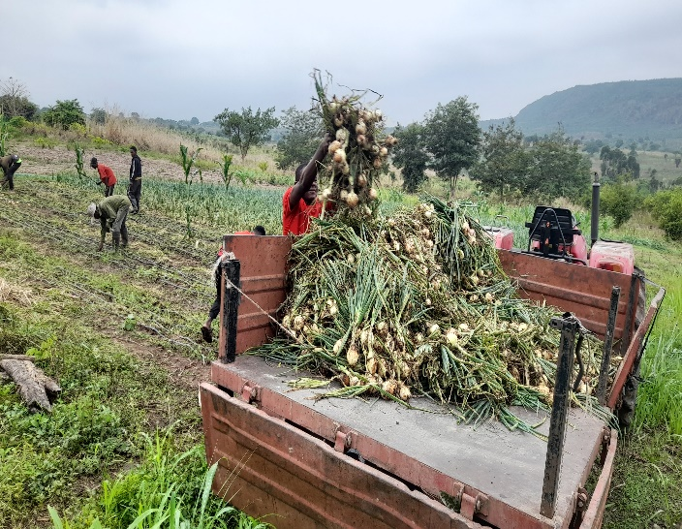
Onion harvesting by students

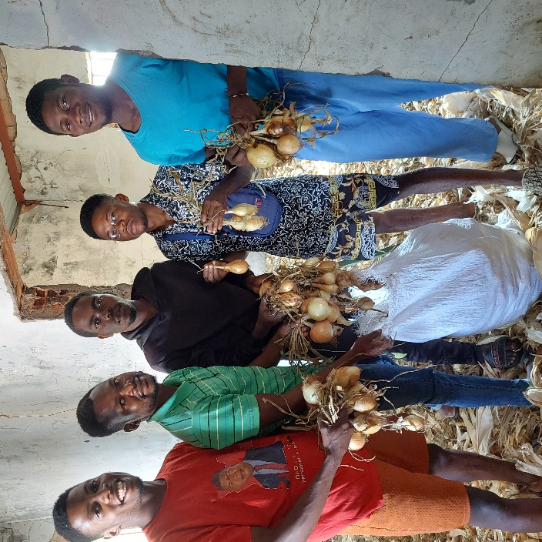
Students collecting harvested onions for the children’s Sunday meals

ADVANCE SPECIAL NUMBERS:
Partner with me,
I am very grateful for the support you continue to give to our project and to myself the missionary. There are two ways to make your contributions:

-Advance # 3022272(Quessua farm project support)
-Advance#3022031(KUTELA salary support)

1. Utilizing the Global Ministries website: www.umcmission.org. To donate for my project and salary support, at the bottom of the page, click on “Missionaries”, scroll to my name on the page and my profile will appear. At the bottom of my profile is a link to make an online donation.

2. Mail a check. Make your check payable to ADVANCE GCFA.Write “For support of Missionary Kutela Katembo.

Advance # 3022272 or # 3022031”Send your check to ADVANCE-GCFA, 458 Ponce de Leon Ave.N.E; Atlanta, GA. 303083. Through your Conference office indicating “for Kutela Katembo”,

STAY IN TOUCH!
I thank you for your support and friendship. Please stay in touch with the Quessua
Agriculture Center Team on the following platforms:
Email: kkatembo@umcmission.org
Facebook: @QuessuaAgCenter

God Bless you! – Kutela

