1Kutela KatemboDieudonne, Missionary Newsletter-East Angola Conference.
Mission: Quessua Agriculture Center
E-mail: kkatembo@umcmission.org/kutelaka@gmail.com Tel: (00244) 925213393
Quessua Agriculture: Advance # 3022272

July 2021
Dear brothers and sisters in Christ, receive our warm greetings from the Quessua Agriculture Center. We hope that our newsletter finds you all well as you are reading this. The Quessua agriculture center as always, would like to extend its deepest gratitude for your prayers and financial support in the achievement of some of its projets with its vulnerable surrounding community and for the development of the Quessua Agriculture Center. We thank God, for working as a team, his mission is being lifted.

Covid 19 up date

The number of covid cases continue to increase in Angola as more and more cases are being detected daily. The capital city Luanda remains the epicenter of covid 19 in Angola. The city is in the red zone with no entry or exit unless one has authorization and the required negative covid test. We thank God that vaccination is still going onand more people are being vaccinated daily.

Livestock
Beef cattle production at the farm is progressing as cows are reproducing. We look forward to obtaining goats for milk production in the near future.We will need to purchase them from Zambia, one of Angola’s neighbors. We need your support for this new project that will help provide milk to our vulnerable communities, especially the malnourished children.

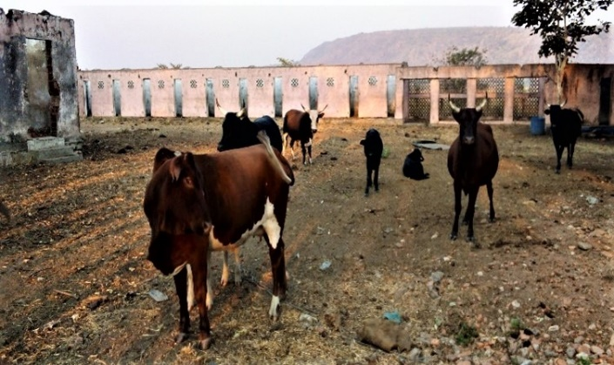

The Quessua mission was in total darkness two months ago for about 15 days due to a power outage resulting from violent winds that took down several big trees that were planted by former missionaries many years ago. Some of these fell on major electric wires and poles that conduct power to the mission buildings. Thank God for the hard work and guidance conducted by the deputy director of the

mission David Schaad who organized and supervised the cutting of treetrunks and reestablishment of power. Generators were used by some but many including the dorms were in the dark at night.

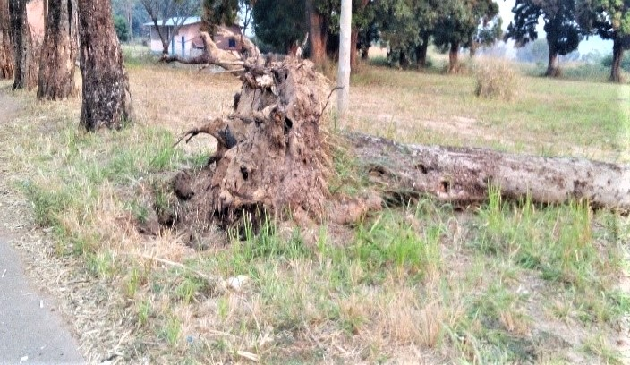

Garden Drip irrigation
Dry season is a favorable time for us to grow vegetables at the farm. Watering is always an issue during this season but we now are able to use drip and flood irrigation thanks to the installation of an electric submersible pump that drives the water into the pipes for this. Onions, tomatoes, cabbage and collard greens are the main vegetables that we plant at the farm.
The installation of the electric submersible pump also allows us to pipe water over to the cattle,sheep, and goat pens at the farm.

Installation of the electric submersible pump

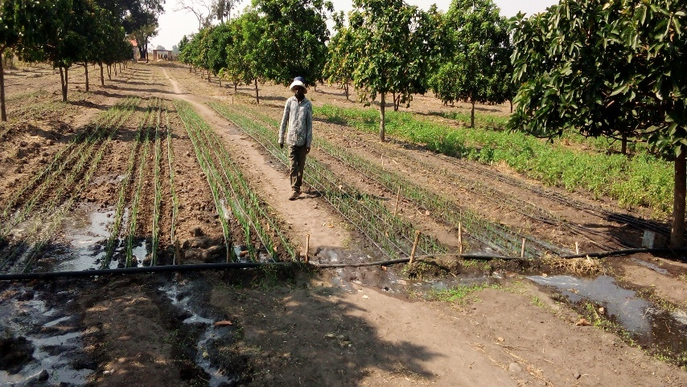
Onions and tomatoes planted in the avocado orchard
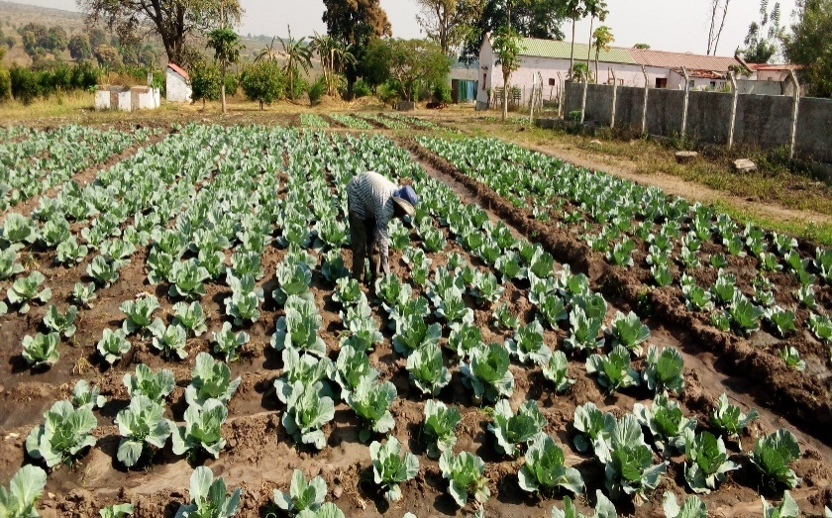
Farm worker Candido weeding the cabbage
Dorm Students,
Both boy’s and girl's Dorm students experienced food shortages during the three remaining months of their school year. Quessua farm was thankfully able to help them with maize and beans and vegetables to help them get by. Students from the boy’s dorm helped harvest the corn and beans; shuck, dehusk, and clean these, then help with the corn milling.This was a new experience to most of the students so they had to be encouraged and taught.
Many of student’s families struggle to support their children, particularly during economic hard times further increased by the pandemic.
We are grateful for the farm mill used for milling corn and manioc into the staple flour. It is a big service to the community that now does not have to go into town for this. Most people that come to the mill do not have extra cash to pay the small token fee thus they pay for services with small amounts of their corn or manioc.
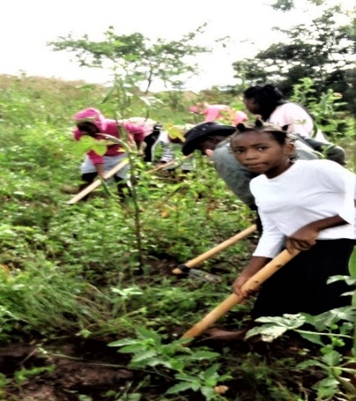
Dorm girls weeding in the okra garden

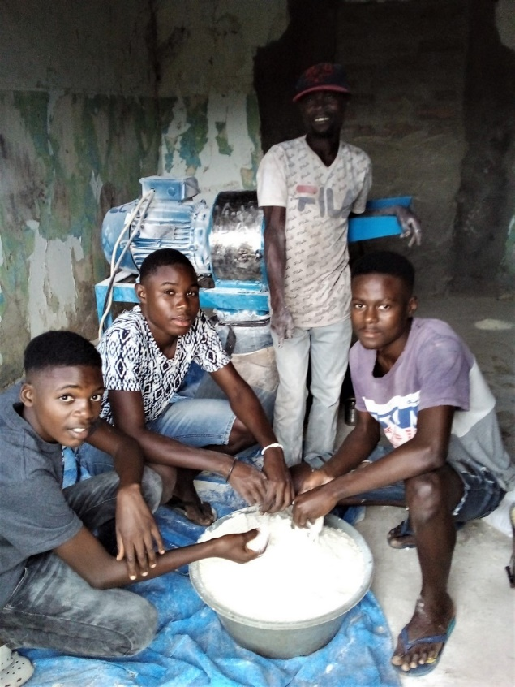
Maize flour milled for the boy’s dorm

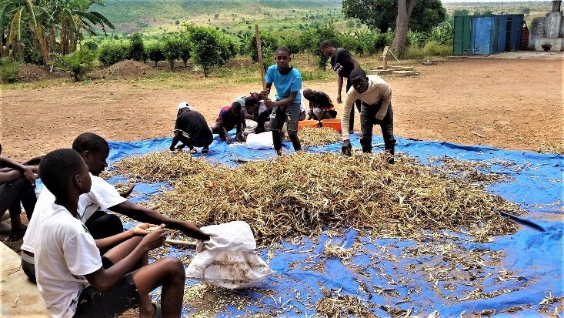
Dorm boys husking beans

ADVANCE SPECIAL NUMBERS:

Partner with me,
I am very grateful for the support you continue to give to our project and to my self the missionary. Your prayers, gifts and moral support make it possible to establish and run the Quessua Agriculture Center destroyed by the civil war. THE ADVANCE is an efficient and safe way to send your financial contributions. There are two ways to make your contributions:

-Advance # 3022272(Quessua project support)

-Advance#3022031(kutela salary support)

1. Utilizing the Global Ministries website: www.umcmission.org. To donate for my project and salary support, at the bottom of the page, click on “Missionaries”, scroll to my name on the page and my profile will appear. At the bottom of my profile is a link to make an online donation.

2. Mail a check. Make your check payable to ADVANCE GCFA.Write “For support of Missionary Kutela katembo.

Advance # 3022272 or # 3022031”.Send your check to ADVANCE-GCFA, 458 Ponce de Leon Ave.N.E; Atlanta, GA. 303083. Through your Conference office indicating “for Kutela Katembo”,

STAY IN TOUCH!

I thank you for your support and friendship. Please stay in touch with the Quessua

Agriculture Center Team and on the following platforms

Email: kkatembo@umcmission.org

Facebook: @QuessuaAgCenter
God Bless you! - Kutela

