Missionary Newsletter from East Angola Annual Conference
Missionary: Kutela Katembo Dieudonne
Mission: UMC Quessua Agriculture Center

E-mail:kkatembo@umcmission.org Tel: (00244) 925213393

October 2023
Dear Faithful brothers and sisters in Christ, I greet you all in the name of our savior and Lord Jesus Christ. It is my pleasure to inform you about my ministry in Quessua mission as we continue together lifting up God’s mission.

Quessua Mission

The Quessua mission is fine and my mission work is doing well by the grace of the Lord. God is blessing us with rains this time of the year and with these new rains we often receive strong, severe wind that shakes everything in its path resulting in uprooted old trees, and roofs of houses blowing off.

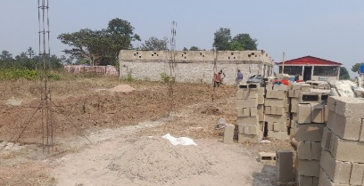
Quessua farm chicken coop under construction

Recently the winds came from the Quessua mountain direction all the way down to the
mission affecting our chicken coop that is under construction. One side of a newly constructed wall fell down but thank God we are catching up with the construction despite the delay in rebuilding the wall that got destroyed. We hope to be finished with it by the end of November.

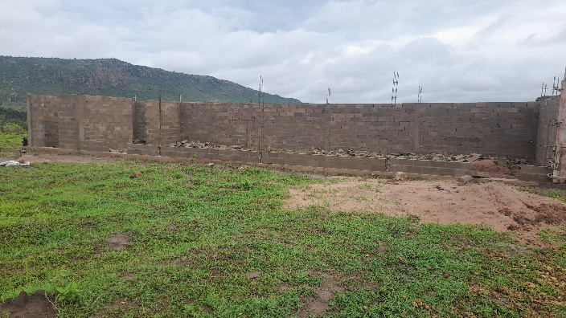

Poultry Project

The main goal of the project is to raise chickens for egg production that will be used to support malnourished children in the villages and contribute to the Sunday school children’s meal every Saturday and Sunday. This will provide extra protein and nutrients to

the healthy meal that is diligently prepared every Saturday and Sunday under the direction of missionary partners leading the children’s meal mission in Quessua. This is a challenging
goal when between 400 to 500 village children are fed each Saturday and Sunday.
Chronic poverty contributes to a high rate of perpetually undernourished children. Most Quessua village households can only manage to provide one meal per day. Toddlers are particularly vulnerable and most school children go to school with no breakfast. Sometimes the most vulnerable have not had a meal the day before.

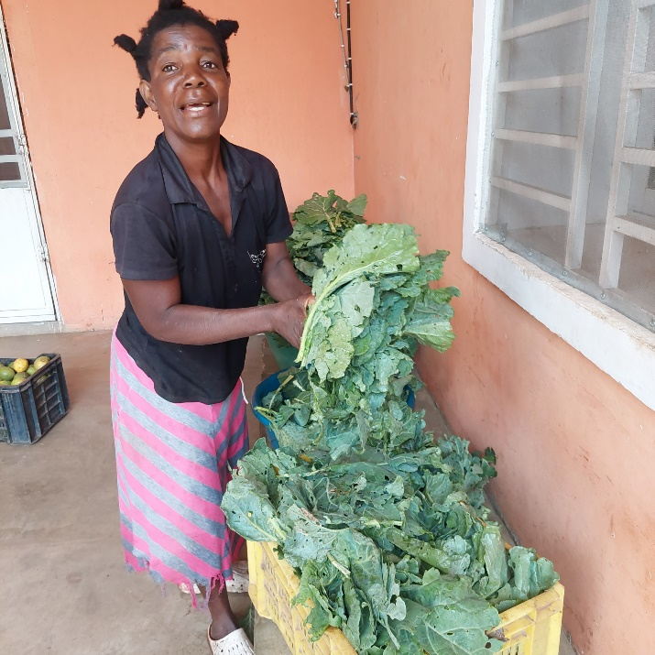

Garden worker Mama Marthe with collard greens she picked for the children’s meal. She is also one of the faithful cooks.

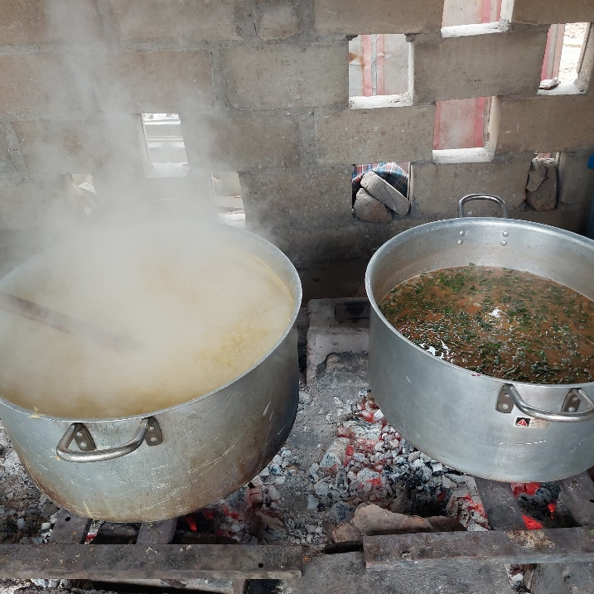

Cooking on the left is funge (the main staple for Quessua people), made with corn and manioc flour. On the right one of three pots of sauce made with chicken, collard greens and roasted ground peanut (also from farm production). The children love this sauce!

Quessua Community support

The village communities we serve receive vegetable seeds from the Quessua farm each planting season and we follow up with them on methods to successfully cultivate these. Sometimes one or two of the communities have disappointing seed beds resulting in poor harvests. This time we decided to plant the seeds in a farm seed bed nursery and once the
seedlings were ready have the communities come receive seedlings to transplant into their individual gardens. This was a positive and productive experience and hopefully a learning one. The community spirit of the people arriving singing together, their leader with them to receive their seedlings is heartwarming and gratifying.
During a visit to one of the gardens we were thrilled to see villagers preparing harvested vegetables for sale.

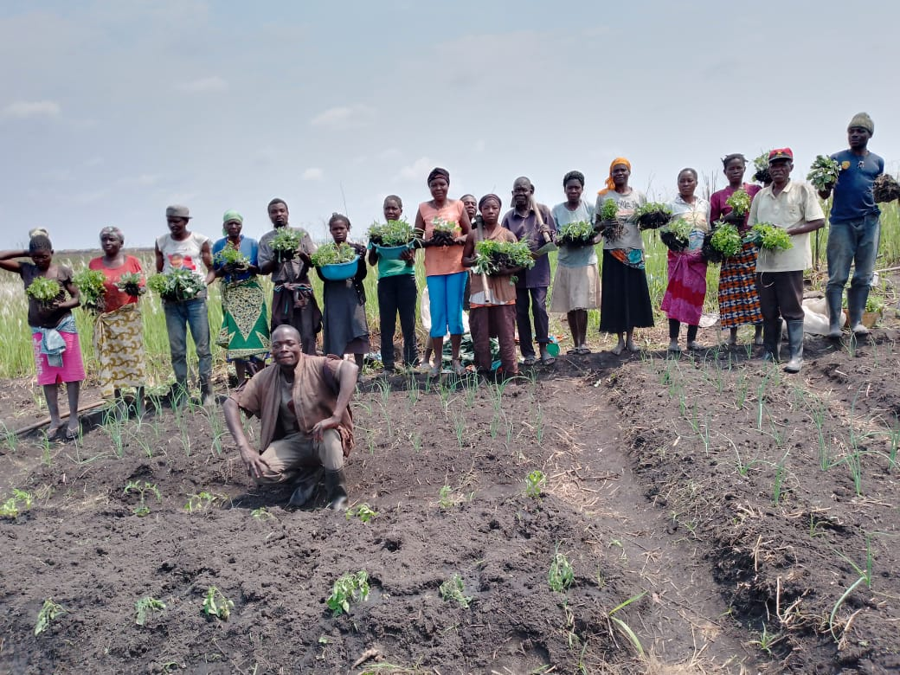

Paz villagers with vegetable seedlings ready to transplant

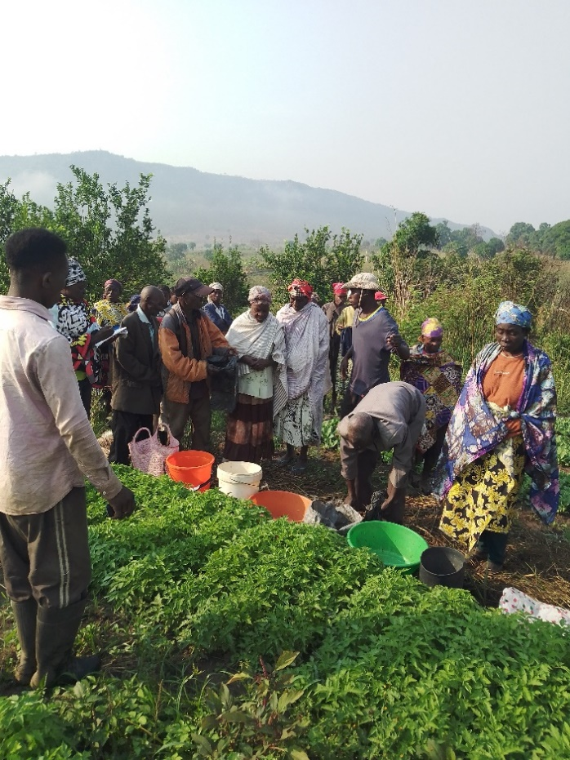

Manga villagers receiving tomato seedlings.

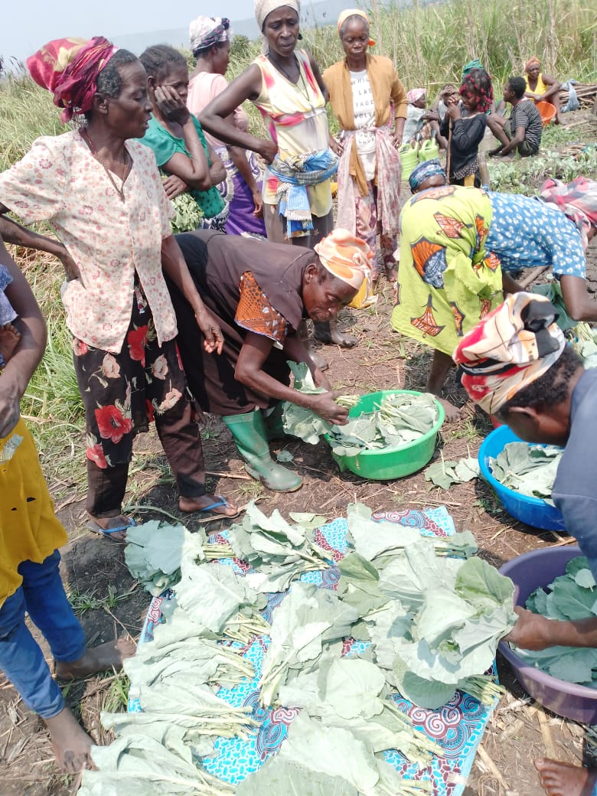

ADVANCE SPECIAL NUMBERS:

Partner with me,
I am very grateful for the support you continue to give to our project and to myself the missionary. There are two ways to make your contributions:

-Advance # 3022272( Quessua Farm Project support)
-Advance#3022031(KUTELA Salary support)

1. Utilizing the Global Ministries website: www.umcmission.org. To donate for my project and salary support, at the bottom of the page, click on “Missionaries”, scroll to my name on the page and my profile will appear. At the bottom of my profile is a link to make an online donation.

2. Mail a check. Make your check payable to ADVANCE GCFA.Write “For support of Missionary Kutela Katembo.

Advance # 3022272 or # 3022031”Send your check to ADVANCE-GCFA, 458 Ponce de Leon Ave.N.E; Atlanta, GA. 303083. Through your Conference office indicating “for Kutela Katembo”,

STAY IN TOUCH!
I thank you for your support and friendship. Please stay in touch with the Quessua
Agriculture Center Team on the following platforms:
Email: kkatembo@umcmissioFacebook: @QuessuaAgCenter

God Bless you! – Kutela

